Transforming NULL or other CSV Data to Acceptable DB Format
When taking a CSV file to import into a SQL database, if that CSV file contains values of NULL, blank or other values you may want to transform (in the case of NULL, the SSIS package will fail attempting to pass a CSV NULL string value to a DB column that allows NULL value type (which is not a string)), in SSIS you use the Derived Column Data Flow function as detailed in this document.
To provide the full picture of the SSIS package and CSV, they will be detailed here for reference.

Creating the Database and CSV file structure and how it appears in the DB table after Successful SSIS package Execution
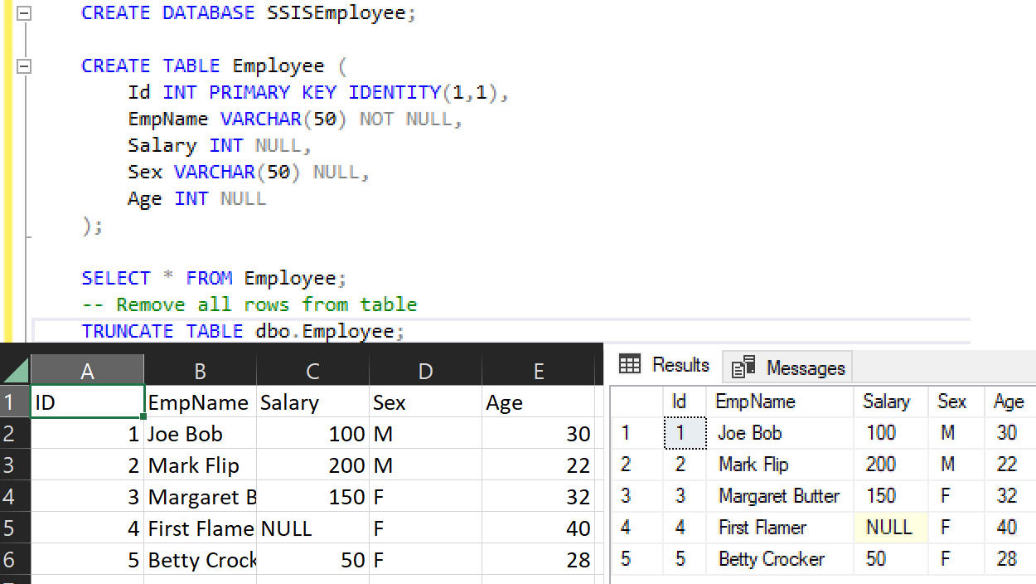
In the table you can see that 3 columns allow NULL values. So, in order for the SSIS package to be able to deal with that type of data there are 3 columns that require explicit data transformations in the event the source CSV contains the text (or string) equivalent of that value type:
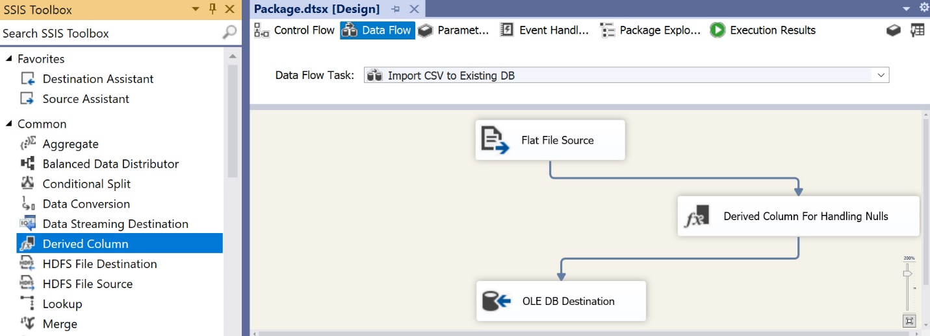
Once the transformation filter has been added, you need to add the logic to handle the 3 columns which allow NULL:
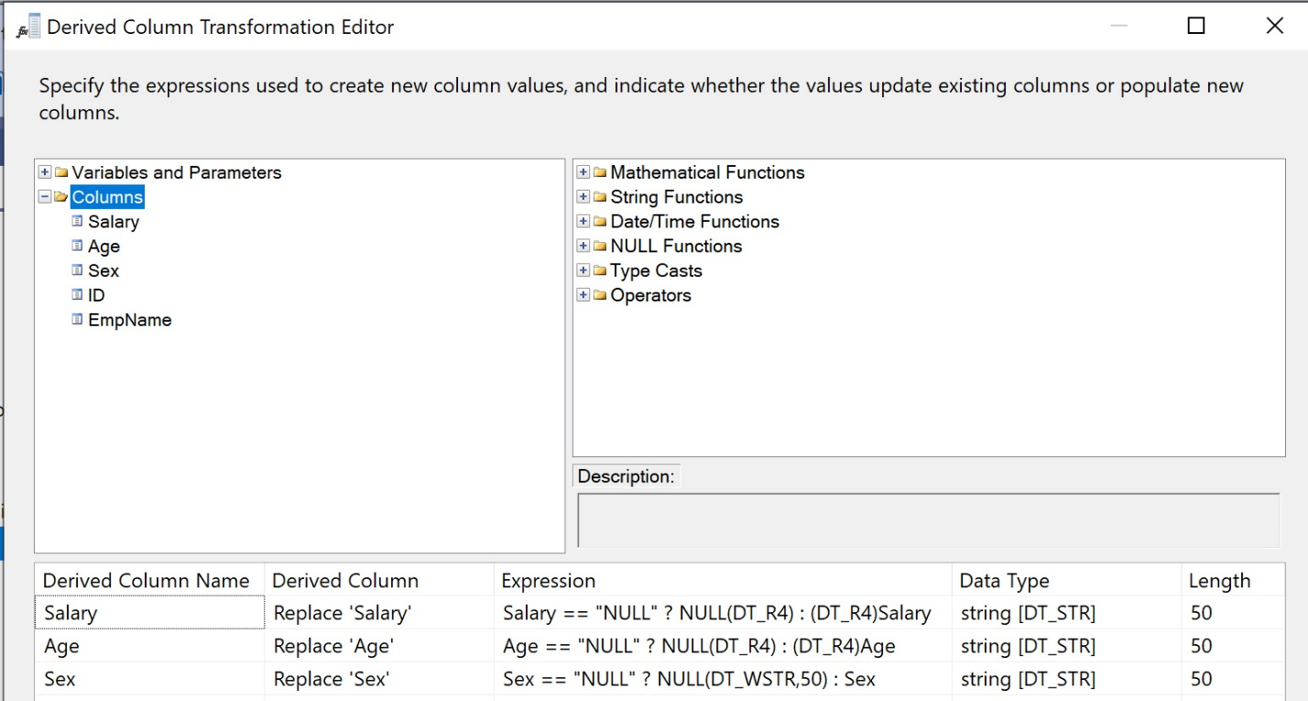
The OLE DB connection will contain the CSV to SQL table mappings (shown below for reference):
